PRESS RELEASE

COMMUNICATIONS AND MEDIA TEAM OF THE 43RD ASEAN SUMMIT 2023

No.87/SP/TKM-ASEAN2023/ENG/9/2023

National Banking Empowers SMEs Through Innovative Financing

Jakarta, 5 September 2023 – The digitalization of internal business processes and the creation of new business models are PT Bank Rakyat Indonesia Tbk (BRI) two primary approaches to offer innovative financing to SMEs. Through these efforts, the national bank empowers SMEs further while mitigating operational risks and reducing operational financing within the company. The President Director of PT Bank Rakyat Indonesia Tbk, Sunarso, stated that digital transformation and innovative financing, which are subthemes of the ASEAN-Indo-Pacific Forum (AIPF), are the company's strategies to boost micro, small, and medium-sized enterprises (MSMEs).

"We see that the most relevant subtheme within the context of ASEAN and the Indo-Pacific is digital transformation and innovative financing because BRI is strategically positioned to support the national and ASEAN economy through SMEs," said Sunarso during the AIPF plenary session in Jakarta on Tuesday.

Internal business digitalization aims to streamline processes and enhance overall operational efficiency. Meanwhile, the creation of new business models through digital means is performed by exploring existing opportunities to increase revenue and add new value to the company.

BRI is one of the companies participating in the inauguration of AIPF, which is part of Indonesia's ASEAN 2023 chairmanship. AIPF serves as a platform for constructive dialogue and promotes inclusive and concrete collaboration between state-owned and private businesses.

AIPF discussions will center on three primary focuses: green infrastructure and resilient supply chains, sustainable and innovative financing, and inclusive digital transformation and creative economy.

The establishment of AIPF is a tangible implementation of the ASEAN Outlook on the Indo-Pacific (AOIP), which was adopted by ASEAN member states in 2019. The AOIP initiative aims to strengthen an inclusive regional architecture, promote collaboration, enhance mutually beneficial cooperation, and seize opportunities in the Indo-Pacific region.

***

For further information, please contact the following:

Director General of Information and Public Communication, Ministry of Communication and Information – Usman Kansong (0816785320).

Find more information at http://asean2023.id, https://infopublik.id/kategori/asean-2023, and https://indonesia.go.id/kategori/ragam-asean-2023.

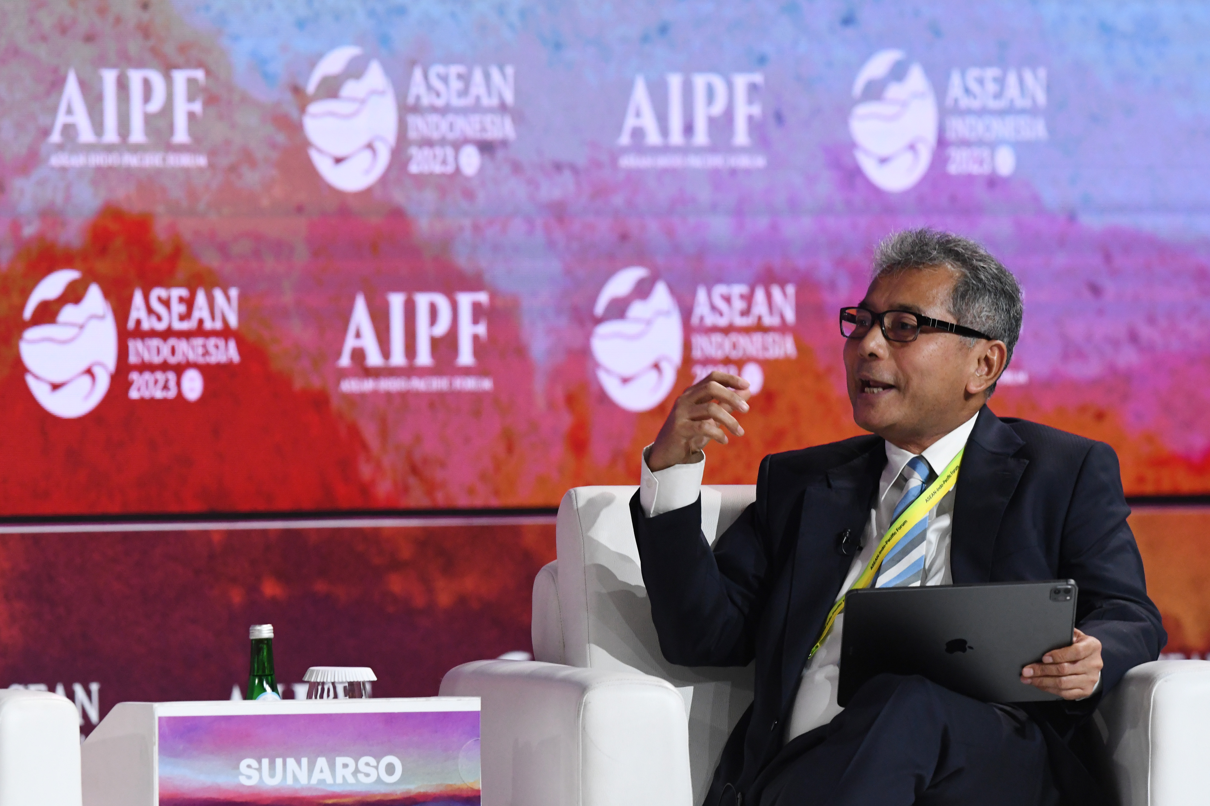

President Director of PT Bank Rakyat Indonesia Tbk, Sunarso, delivering his presentation as a speaker in Plenary Session 2 "Quick Glance on the three AIPF Subthemes" at the ASEAN Indo-Pacific Forum (AIPF) in Jakarta, Tuesday, 5 September 2023. ANTARA FOTO/Media Center KTT ASEAN 2023/Dhoni Setiawan/aww.

